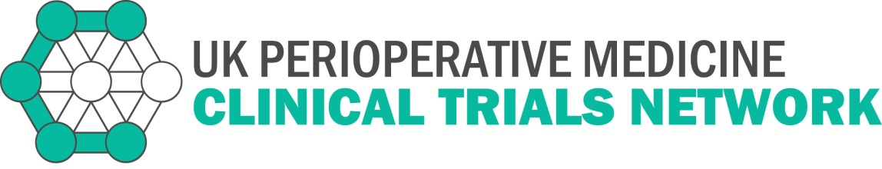
APPLICATIONS OPEN FOR CHIEF INVESTIGATOR SCHEME
UK Perioperative Medicine Clinical Trials Network
The UK Perioperative Medicine Clinical Trials Network (POMCTN) is opening the application process for its Chief Investigator mentoring scheme. The Chief Investigator scheme is intended to provide training and mentorship for a small number of talented individuals who wish to lead their own clinical trials in perioperative medicine.

Eligibility
Applicants will be existing members of the POMCTN Local or Principal Investigator scheme, with a proven track record of recruitment to clinical trials. They will also ideally have the experience of a complete research cycle as a grant co-applicant, from outline application through to publication and dissemination of results. Previous experience of reviewing topic journal papers, grant applications or similar tasks is desirable. Applications are welcomed from individuals of any clinical background of relevance to perioperative medicine. Those who would like to discuss the position informally before applying can contact the POMCTN Help Desk.

Role
Successful appointments to the POMCTN Chief Investigator Scheme will be expected to attend three training days each year, at which experienced researchers will lead discussions, exchange of views and problem based tutorials covering important practical and theoretical topics in the delivery of multicentre randomised controlled trials. All relevant topics will be covered over a period of three years. They will be attached to an established chief investigator on an existing clinical trial who will provide mentorship and exposure to the processes and governance of the study, including attendance at appropriate trial committee meetings as an observer. Candidates who have a pre-existing relationship of this type already in place can be accommodated on the scheme.

Background
POMCTN is funded by the National Institute of Academic Anaesthesia (NIAA) founding partners and the Rosetree Trust. Its aim is to identify, develop, support and coordinate the efficient delivery of large scale clinical trials in order to improve the health outcomes of patients receiving perioperative care in the UK, promoting engagement both with the research and assists and contribute to the successful implementation of research findings. The Network supports projects involving the recruitment of patients where the aim is to improve outcomes following surgical treatment (not research into surgical techniques). The Network has already established a process of recruiting and accrediting local and principal investigators for clinical trials. These schemes provide training days and other resources to support and develop investigators in individual hospitals or training schemes.

For further information please contact: pomctn@niaa.org.uk

How to apply: Please send in your covering letter and your cv to pomctn@niaa.org.uk
Closing date for applications: 27th January 2020 at 12pm
Interview date: 27th February 2020

