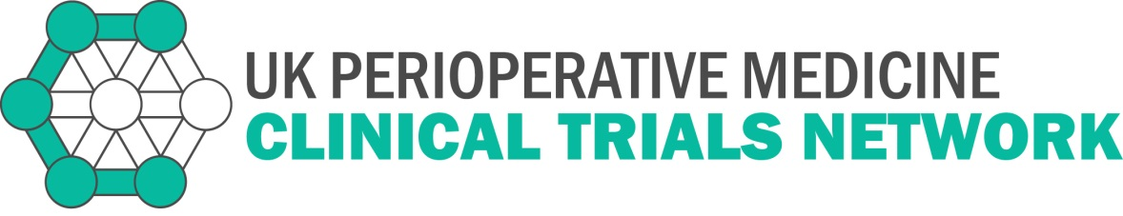
New Study Proposal Template - Full
If you would like to discuss presenting your study at future meetings, please email:
pomctn@niaa.org.uk

1. Study identifier
Full title of study
Acronym (If applicable)
Presenting applicant
Name
Address
Telephone
Email
Senior investigator (if not presenting)*
Name
Email

* Please note: if your senior investigator is not presenting, it would be helpful if they were present at the meeting to assist with questions from the audience

2. The need for the study
Give a brief summary of the proposed study in no more than 100 words.
What are the principal research questions to be addressed?
Why is the study needed now?
How will the results of this study inform clinical practice?
E.g. inform clinical decision-making /improve understanding.

3. The proposed study
What is the proposed study design?
What are the planned interventions (if applicable)?
What are the proposed arrangements for allocating participants to groups
(if applicable)?
What are the proposed methods for protecting against sources of bias?
e.g. blinding or masking. If blinding is not possible please explain why and give details of alternative methods proposed or implications for interpretation of the study’s results.
What are the planned inclusion/exclusion criteria?
What is the proposed duration of intervention period (if applicable)?
What is the proposed frequency and duration of follow up?
What are the proposed outcome measures?
Primary:

Secondary:

How will the outcome measures be measured at follow-up?
What is the proposed sample size? Include statistical justification, such as power calculation(s)
What is the planned recruitment rate? (Please include estimates of the number of site(s) involved and recruitment projections with evidence of feasibility.
Describe any Patient and Public Involvement in the proposal.
Proposed funding source if not already funded/Funding source if funded
What is the Dissemination Plan?

Length of presentation will be 20 minutes followed by 10 minutes for discussion.

Please note that in the event of a study proposal being accepted by POMCTN, we reserve the right to reproduce information submitted in this form for the purpose of publicising the study adoption.

